## **Project “Sammy” 1-Page GDD**

Snakes for the modern age.

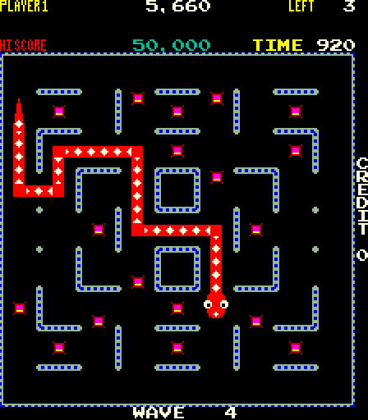

**Genre:** Arcade puzzle, Snakes/Nibbler style game.  
**Target Audience:** All ages, Casual gamers.

**Controls:** touch, keyboard, mouse and maybe controller.

**Thematic Setting:** garden, lab, forest and or sewers, classic.

**Tech Stack:**

**Platform(s):** mobile, web/PC maybe console

**Game Moment:** chase down and eat rats to get bigger, careful not to bite your tail!!!

**Game Summary:** chase down and eat rats to get bigger, careful not to bite your tail!!!

**Core Player Experience:**

**Central Theme:**

**Design Pillar:**

**Anticipated Remarkability:**

**Anticipated App Store Launch date:** 1/12/17

**Feature Development Priorities:**

**Comparative Products:**